Team Meeting Log
Group 3 | Meeting Log #2 | 1/30/2021 | 60 Minutes
Team Members | Dane Manley | GUI skeleton | 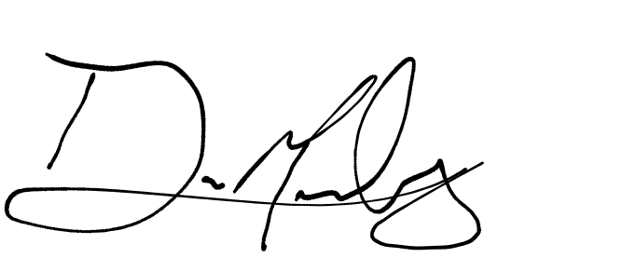
Team Members | Santiago Ramirez | Git Organization
Team Members | Daniel Espinel | Git Management/Readme | 
Team Members | Anthony Peterson | First Meeting (N/A) | AP
Topics Discussed |  | - Divide the work  - Anthony: Arithmetic  - Santiago: I/O, Load/Store  - Daniel: Control  - Erik: GUI, Hard-Copy/backup  - Fix our Git situation
Obstacles Encountered |  | - Git  - Mic Issues  - Team call issues
Finished Items |  | - Git situation all fixed  - Branches fully implemented  - Permissions fixed  - We now know how to use it right  - Backlog organized
Unfinished Items |  | - Operations, GUI
Notes

